The Conversion of the So-Called Good Person

Fordham Preparatory School
March 6, 2021
Brian B. Pinter (pinterb@fordhamprep.org)

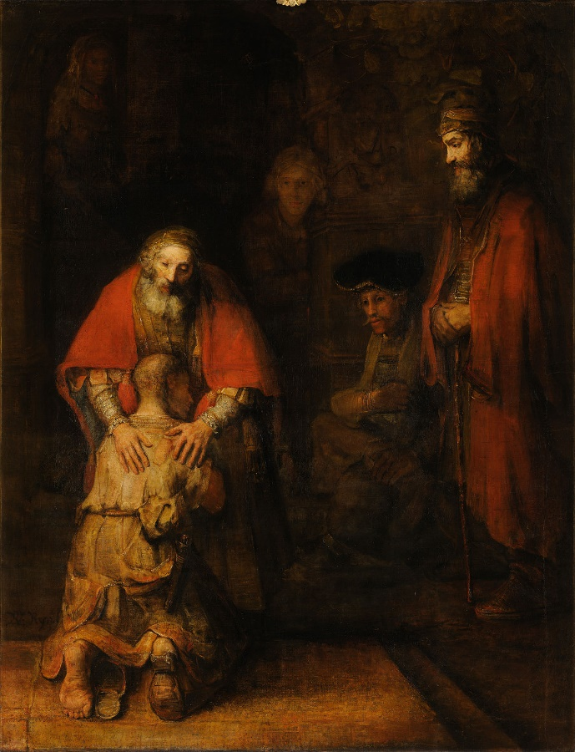

Please feel welcome to post questions/comments in the chat feature of zoom.

Theme: How does the “good” person go deeper into relationship with God, become more authentic, continue to grow in spiritual maturity? (This is what we mean by “conversion”…)

Introduction:

Example from dreamwork: Life review…. God asks “How much have you
loved?”…Good person replies, “That’s the wrong question…”

- Good people have kept the commandments, attended to responsibilities, given themselves to others. Does conversion mean one has to be “more good”?

Luke 15 – (this parable illustrates the spiritual struggles of the “good person”)…
²⁵ “Now his elder son was in the field; and when he came and approached the house, he heard music and dancing. ²⁶ He called one of the slaves and asked what was going on. ²⁷ He replied, ‘Your brother has come, and your father has killed the fatted calf, because he has got him back safe and sound.’ ²⁸ Then he became angry and refused to go in. His father came out and began to plead with him. ²⁹ But he answered his father, ‘Listen! For all these years I have been working like a slave for you, and I have never disobeyed your command; yet you have never given me even a young goat so that I might celebrate with my friends. ³⁰ But when this son of yours came back, who has devoured your property with prostitutes, you killed the fatted calf for him!’ ³¹ Then the father said to him, ‘Son, you are always with me, and all that is mine is yours. ³² But we had to celebrate and rejoice, because this brother of yours was dead and has come to life; he was lost and has been found.’”

For Reflection (you are welcome to post an answer to this through the “chat” feature): What is the energy of this passage, specifically the elder, “good” son?

The “Good Son” symbolizes how superficial goodness can build up deep darkness – resentment, anger, repressed sexual issues, struggle with forgiveness, making contracts, passive/aggressiveness (I won’t go in – that will punish them!); the ultimate struggle for the good person might be accepting unconditional love.

Point 1 Conversion is scary because the “good person” has a lot to lose.
Matthew 19 ¹⁶ Then someone came to him and said, “Teacher, what good deed must I do to have eternal life?” ¹⁷ And he said to him, “Why do you ask me about what is good? There is only one who is good. If you wish to enter into life, keep the commandments.” ¹⁸ He said to him, “Which ones?” And Jesus said, “You shall not murder; You shall not commit adultery; You shall not steal; You shall not bear false witness; ¹⁹ Honor your father and mother; also, You shall love your neighbor as yourself.” ²⁰ The young man said to him, “I have kept all these; what do I still lack?” ²¹ Jesus said to him, “If you wish to be perfect, go, sell your possessions, and give the money to the poor, and you will have treasure in heaven; then come, follow me.”
- Follow Jesus? But he associates with the “bad”… What would have been the conversion for the rich young man?

John 3 Now there was a Pharisee named Nicodemus, a leader of the Jews. ² He came to Jesus by night and said to him, “Rabbi, we know that you are a teacher who has come from God; for no one can do these signs that you do apart from the presence of God.” ³ Jesus answered him, “Very truly, I tell you, no one can see the kingdom of God without being born from above.”
- goodness causes Nic to hide, follow Jesus in secret; didn’t want to lose his name/reputation. What would have been the conversion of Nicodemus?

Sr. Helen Prejean: She’s the “good sister” until she befriends and cares about a murderer.

Pause for comment/question…

Point 2 What are the spiritual tasks of the “good person”? Some probing questions…
- Can I face and accept the depths of who I am, including the shadow (all those things about myself that I repress and would rather not know)?$†$ (We’ll come back to Shadow later…)
- Has my “goodness” been a coping mechanism (alcoholic/addiction systems)? Was I good because I needed to be the hero of the family?†
- Is my “goodness” based on repression of authentic emotion I am afraid to acknowledge? (Anger, resentment, jealousy; am I passive/aggressive; other “frozen emotion” that I cannot feel because “good people” don’t do that?…)†
- Is my goodness rooted in perfectionism/pleasing/performance (the unholy trinity)? Have I made a contract with God? (Often characterized by denial, need to control, dependence on positive feedback, fear of change/ambiguity, self-righteousness, need to be constantly busy, avoiding grieving -because it’s messy…)†
- Can I truly accept that I am loved unconditionally, and not based on my “pleasing” others or performing? (For the “good person”, unconditional love can be terrifying.)†
- Does codependency characterize my life and relationships? (My emotions and behaviors are dictated by the stress of the situation rather than internal cues from my deeper Self.)†
- Am I “good” as a way of avoiding stressful situations and having to deal with real issues? (Do I take on tasks so as to avoid conflict and stress, but then I create more stress for myself?)†
- Do I have a messiah complex? (I feel the need to fix myself and others; save loved ones who are “lost”). †
- Is my life unbalanced - eg workaholism? Do I neglect self-care because I am taking care of everyone else? Have I been performing and pleasing for so long I don’t know what my needs are? Can I distinguish between love and doing for others?†
- Have I come to a point where I need God, and not just have a desire for God? (the prodigal needs the father…)†

Point 3 Shadow Boxing

- What is shadow? Everything about myself I don’t know and don’t want to know.
- Where and when does shadow make itself known?
  - Makes decisions for me (when unconscious) – we ask “where did this come from”?
  - I see it clearly in someone else – energy I dislike in me I see in the other.
  - I live it out; choose to live out of compulsed, instinctual self. Gifts are suppressed; live out of a dark place. Drugs and alcohol can release it.
- How do I do shadow work? (see quote from Richard Rohr below)
  - Self-awareness: paying attention to when we’re stirred, unsettled, triggered.
  - Withdrawing projections.
  - Dialogue with shadow – what is this part of me that has been suppressed/split off, looking for integration.
  - 10% of shadow is not integratable we must cling to God and goodness in this part of shadow’s presence. This is archetypal evil and can over-power us.
- The Paradox of “Goodness” and Prayer
  - Prayer/meditation will allow what is suppressed to come forward; the shadows deep within. The more you do spiritual work, the more the demons will come forward, i.e. my own darkness and capacity for darkness.
  - The “Divine Therapist” evacuates unconscious material.
    - Excerpt from Putting on the Mind of Christ by Jim Marion
Whatever the nature of the demons one encounters through the spiritual passage there is no need to condemn them, fear them, or run away from them. The terrible psychic pain of this transition is… to unlock all these repressed parts of us. … And the length of the passage is also a result of resistance, condemning, fearing, running away from or fighting these demons … increases the resistance and pain and prolongs the agony.
The meditator should stop judgments and look upon those damaged parts of the soul and any negative spirits that may be attached to them with compassion. The meditator should relax, surrender to God, and trust and simply allow the healing process to do its work quickly and with the minimum of resistance and pain. Normally however this is advice more easily given than heeded by the person desperate to maintain his or her social and church approved image of being a good person.
As John (John of the Cross) says, the encounter with the demon is a great torment and sometimes a pain worse than death because it is profoundly embarrassing and humiliating to the person who took pride in his/her own goodness. The last thing we want to admit is having inner demons of any kind, let alone showing compassion for those damaged parts of ourselves.
    - Acknowledging these demons puts us on the path to compassion and community (I am as much a paradox as anyone else, with the same capacity for darkness.)
    - Transformation/conversion comes from facing who we are, not who we should be. (unfortunately religion often is not helpful with this – more focused on who we should be.)

Discussion Questions:
- What resonates with you?
- What content in this presentation especially attracted or repelled you?
- Which among the “probing questions” under “point 2” speaks to you?
- Where, how, and when do you encounter your shadow? What stirs shadow for you? How might you be experiencing the call to do shadow work?
- How are you being called to “conversion” to a deeper, more authentic goodness?

